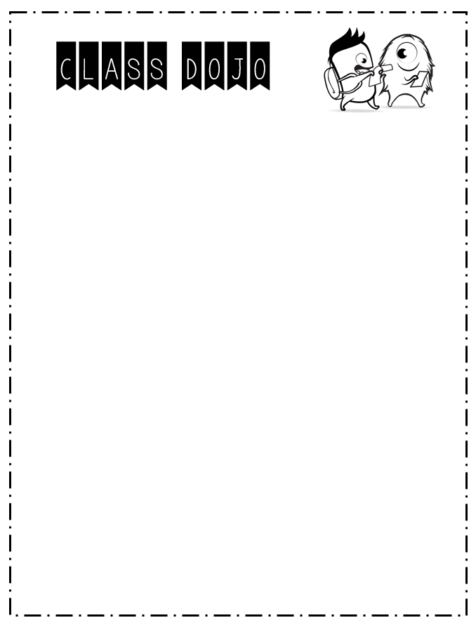

Dear Families,

This year I will be using a web-based program called Class Dojo to help track students’ behavior. It is an excellent communication tool to help keep parents updated about their child’s behavior.

In Class Dojo, students can earn points for positive behaviors such as being on task, following directions, helping others, etc. Students can also lose points for negative behaviors such as being off task, not following directions, etc. Students love being able to track their points.

Once you have joined our class you will be able to check your child’s progress anytime. You will also be emailed a report every Friday. Students can create their own account so they can check on their own progress as well. (There’s even an app!) Parents love having instant access to how their child is doing. Another great feature of Class Dojo is the ability for me to send messages to parents.

Our Classroom Clipchart goes along with Class Dojo and will be used with a substitute teacher. If you have any questions feel free to contact me.

Sincerely,

Mrs. Paparella

